**Enhancing Binary Particle Swarm Optimization for Graph Coloring Problem**

**Motivation:**

Graph coloring is a classic NP-hard optimization problem with applications in scheduling, resource allocation, and network design. The Graph Coloring Problem is a challenging optimization task with practical relevance.

Traditional algorithms may struggle with large and complex graphs. Binary Particle Swarm Optimization (BPSO) has shown promise in solving combinatorial optimization problems. This research proposes enhancements to BPSO for the Graph Coloring Problem (GCP), aiming to improve its efficiency, convergence speed, and solution quality.

**Problem Statement:**

The Graph Coloring Problem involves assigning colors to the vertices of a graph in such a way that no adjacent vertices share the same color. The objective is to minimize the number of colors used. BPSO, when applied to the GCP, requires modifications to better handle the discrete and binary nature of the problem.

**Objectives:**

The primary objectives of this research are:

* To improve the binary encoding scheme used by BPSO to represent and manipulate graph coloring solutions more effectively.
* To integrate a local search mechanism within the BPSO algorithm to refine solutions and enhance the convergence speed.
* To develop mechanisms for dynamically adjusting BPSO parameters based on the progress of the optimization process, ensuring adaptability to different graph structures.
* To evaluate the enhanced BPSO algorithm against existing state-of-the-art graph coloring algorithms using standard benchmark datasets. Assess its efficiency, solution quality, and scalability.

**Expected Outcomes:**

The anticipated outcomes of this research include:

* A modified BPSO algorithm specifically designed for the GCP, featuring improved binary encoding, local search integration, and dynamic parameter tuning.
* Demonstrated enhancement in the quality of graph coloring solutions, minimizing the number of colors used while maintaining feasibility.
* Evaluation of the enhanced BPSO against existing graph coloring algorithms, showcasing its competitive advantages in terms of efficiency and solution quality.

**Methodology:**

Binary Encoding Enhancement: Refine the binary encoding representation to better capture the unique characteristics of the GCP, ensuring feasibility and accuracy in representing valid color assignments.

Local Search Integration: Integrate a local search strategy within the BPSO framework to exploit the local neighborhood and refine solutions. This enhances the algorithm's ability to navigate the solution space effectively.

Dynamic Parameter Tuning: Implement mechanisms for dynamically adjusting BPSO parameters, such as inertia weight and acceleration coefficients, based on the algorithm's performance during runtime.

Algorithm Validation: Validate the enhanced BPSO algorithm using standard benchmark datasets for the GCP. Compare its performance against existing algorithms in terms of solution quality and computational efficiency.

Conclusion:

This proposal outlines a research plan to enhance Binary Particle Swarm Optimization for the Graph Coloring Problem. The proposed modifications aim to address the specific challenges of the GCP and contribute to the development of more effective optimization algorithms for combinatorial problems.

Reference:

Combinatorial optimization problems are common in various domains and involve finding the best combination or arrangement of decisions or objects from a finite set of possibilities. However, solving these problems is challenging due to exponential growth in possible solutions, constraints, variables, non-convexity, and NP-hardness. Efficient optimization algorithms are required for solving real-world problems within a reasonable amount of time.

Several optimization algorithms have been developed and successfully used to solve combinatorial optimization problems, such as Genetic algorithm (GA), Binary Particle Swarm Optimization (BPSO), Simulated Annealing (SA), Tabu Search (TS), and Ant Colony Optimization (ACO) [1]. BPSO is a particularly popular and powerful algorithm, known for producing good results and having a low computational cost. It has been applied to a wide range of optimization problems and is relatively easy to implement [2]. In BPSO, balancing between exploration and exploitation is necessary to ensure the optimization process's speed and accuracy. Exploration refers to the process of searching different regions of the solution space to find new solutions, while exploitation refers to the process of refining the best solutions found so far. To make this balance, exploration is important in the early stages of the run to avoid getting stuck in local optima, while exploitation is important in the later stages of the run to refine the solution quality [3]. In BPSO, the search space considers as a hypercube (see Fig. 1), where particles move by flipping one or more bits in their position vector.

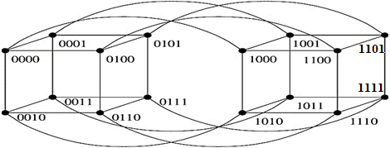

Figure 1: Illustration of a binary search space consists of 4 binary decision variables.

BPSO uses a transfer function that depends on the particle's velocity to determine the probability of each bit being 0 or 1. A high absolute velocity leads to exploitation, while a small absolute velocity leads to exploration. It is reported that BPSO has been found to struggle with achieving a balance between these two processes, mainly due to issues related to the velocity and sigmoid function [3]**.** Over the last decades, researchers have developed multiple variations of BPSO to address the limitations of the original BPSO in three distinct approaches. The first approach involves the development of new position updating equations, as done by Shen et al. [4]. The second approach involves modifying the inertia weight parameter (*w*), as attempted by Liu et al. [5]. Lastly, some researchers have proposed modified transfer functions to achieve balance between exploration and   
exploitation [3, 6-8].

The initial investigation of this research has revealed that existing BPSO algorithms continue to face difficulties in achieving a balance between exploration and exploitation within the search space. Considering the above issue, this work presents a modified BPSO algorithm that addresses the limitations of current BPSO variants by integrating the time-varying velocity control strategy. Moreover the algorithm is intended to produce superior quality solutions for a range of combinatorial optimization problems. To achieve this goal, the following objectives have been established for the research.

**10. Objectives with specific aims, possible outcomes:**

**Objectives:**

The specific objectives of this research are as follows:

1. To analyze the search behavior of Binary PSO algorithms and identify their limitations in balancing exploration and exploitation.
2. To design a modified Binary PSO algorithm that uses a time-varying velocity control strategy to efficiently balance exploration and exploitation of the search space.
3. To evaluate the performance of the modified Binary PSO algorithm and compare it with other existing Binary PSO algorithms and metaheuristic algorithms on standard benchmark problems.

**Possible Outcomes:**

Possible outcomes of the proposed research are as follows:

1. A modified Binary PSO algorithm that utilizes a time-varying velocity control strategy to achieve more efficient balance between exploration and exploitation of the search space compared to the existing Binary PSO algorithms
2. A comprehensive evaluation of the performance of the modified Binary PSO algorithm using standard benchmark problems.

**11. Outline of Methodology/ Experimental Design:**

The research proposes a modified version of Binary Particle Swarm Optimization (BPSO) that overcomes the limitations of existing variants. The proposed BPSO employs a time-varying velocity control strategy to balance exploration and exploitation of the search space. This study builds on the original BPSO and incorporates the time-varying concept. The proposed BPSO uses a population of binary particles to search for the optimal solution in the solution space. The particles communicate with each other to update their velocity (***v***) and position (***x***) based on their individual best solution (***p***) and the global best solution (***g***) found so far by the entire population using the following equation:

$v_{ij}^{t+1}=v_{ij}^{t}+c_{1}r_{1}\left(p_{ij}^{t}-x_{ij}^{t}\right)+c_{2}r_{2}(g_{j}^{}-x_{ij}^{t})$ (1)

Real-world applications of BPSO often require problem-specific velocity clamping techniques to prevent particles from overshooting optimal solutions, which can lead to poor convergence and suboptimal performance. These techniques limit particle velocity using a pre-defined threshold value, *Vmax*. However, existing BPSO variants struggle to balance exploration and exploitation effectively [3, 8]. To address this issue, the proposed research will use a time-varying velocity control strategy, incorporating a time-varying *Vmax* instead of a fixed *Vmax* used in existing algorithms. The equation for the time-varying *Vmax* is presented in Equation (4) and is expected to improve exploration and exploitation balance in BPSO.

$V_{max}=V_{l}+g×(V_{h}-V_{l})/maxItr$ (2)

Where $V_{l}$, $V_{h}$ represent the lower and upper limit of Vmax,  represent the current and maximum number of generations, respectively.

The proposed BPSO algorithm sets the velocity of each particle to be within the time-varying $V_{max}$. This restriction ensures that the particle's velocity aligns with the value of $V_{max}$, which helps to balance the exploration and exploitation of the search space. After clamping the velocity in this manner, it updates the position of each particle using Equ. 2.

${ x}_{ij}^{t+1}=\left\{\begin{aligned}1 if rand\left(\right)<S(v_{ij}^{t+1}) \\ 0 otherwise \end{aligned}\right.$ (3)

where S is a sigmoid function which provides a bit flipping probability depending on the clamped particle velocity. In proposed BPSO, the velocity and position update equations are repeated for a certain number of iterations until the stopping criteria are met, such as a maximum number of iterations or a satisfactory solution is found. The flowchart of the proposed modified BPSO is illustrated in Fig. 2.

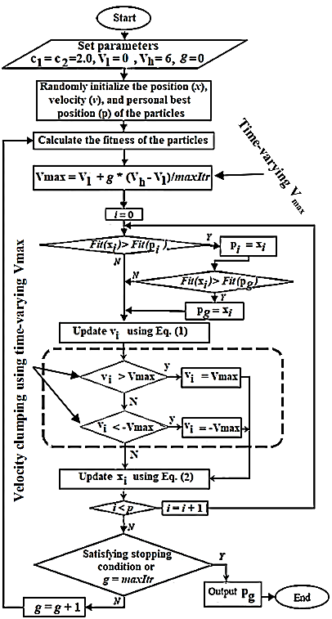

Figure 2: Flowchart of the proposed modified BPSO.

The performance of the proposed Binary PSO algorithm will be evaluated using standard benchmark problems such as the 0-1 knapsack problem and multidimensional 0-1 knapsack problem [3, 8]. The evaluation metrics will include solution quality, convergence speed, and algorithm robustness.

**12. References:**

1. F. Peres and M. Castelli, "Combinatorial Optimization Problems and Metaheuristics: Review, Challenges, Design, and Development," *Applied Sciences*, vol. 11, no. 14, pp. 6449, 2021.
2. J. Kennedy and R. C. Eberhart, "A discrete binary version of the particle swarm algorithm," in *Proceedings of the 1997 IEEE International Conference on Systems, Man, and Cybernetics. Computational Cybernetics and Simulation,* Orlando, FL, USA, Oct. 1997.
3. M. J. Islam, X. Li, and Y. Mei, "A time-varying transfer function for balancing the exploration and exploitation ability of a binary PSO," *Applied Soft Computing*, vol. 59, pp. 182-196, 2017.
4. Q. Shen, J.-H. Jiang, C.-X. Jiao, G.-L. Shen, and R.-Q. Yu, "Modified particle swarm optimization algorithm for variable selection in MLR and PLS modeling: QSAR studies of antagonism of angiotensin II antagonists," *European Journal of Pharmaceutical Sciences*, vol. 22, no. 2-3, pp. 145-152, 2004.
5. J. Liu, Y. Mei, and X. Li, "An analysis of the inertia weight parameter for binary particle swarm optimization," *IEEE Transactions on Evolutionary Computation*, vol. 20, no. 5, pp. 666-681, 2016
6. T. K. Truong, "Different transfer functions for binary particle swarm optimization with a new encoding scheme for discounted {0-1} knapsack problem," *Mathematical Problems in Engineering*, vol. 2021, pp. 1-7, 2021.
7. S. S. Guo, J. S. Wang, and M. W. Guo, "Z-shaped transfer functions for binary particle swarm optimization algorithm," *Computational Intelligence and Neuroscience*, vol. 2020, 2020.
8. Z. Beheshti, "A novel x-shaped binary particle swarm optimization," *Soft Computing*, vol. 25, pp. 3013-3042, 2021.